* **Title of Project**-: **IOT Belt (Group Number 1)**
* **Group Members:-**

1. **Tanish Sahijwani**
2. **Ganesh Gaonkar**
3. **Pranay Pagare**
4. **Prathmesh Indalkar**
5. **Priya Gangwani**

* **Internet of things-:**

The Internet of Things (IoT) is a network of physical objects—devices, vehicles, buildings and other items embedded with electronics, software, sensors, and network connectivity—that enables these objects to collect and exchange data. IoT allows objects to be sensed and controlled remotely across existing network infrastructure, creating opportunities for more direct integration between the physical world and computer-based systems, and resulting in improved efficiency, accuracy and economic benefit.

* **Required Components-:**

1. **DS18B20 Temperature Sensor-:**

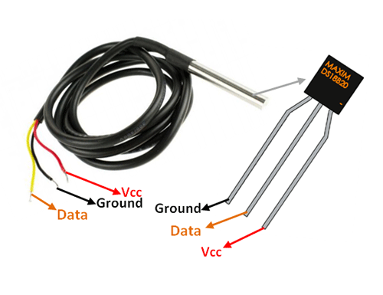

Domestic animal has a core body temperature (CBT) which gives an indication of their body temperature. Any deviation from their usual temperature is a cause for abnormality. For example, a domestic cow has body temperature between 38.0-39.3 degree Celsius. Whereas, for a dog it is between 37.9-39.9 degree. And any deviation from these temperatures can tell us that there is an abnormality. And hence to measure this, we use DS18B20 temperature sensor. The DS18B20 is rated to operate over a −55° to +150°C temperature range.

* **DS18B20 Sensor Specifications-:**
* Programmable Digital Temperature Sensor
* Communicates using the 1-Wire method
* Operating voltage: 3V to 5V
* Temperature Range: -55°C to +125°C
* Accuracy: ±0.5°C
* Output Resolution: 9-bit to 12-bit (programmable)
* Unique 64-bit address enables multiplexing
* Conversion time: 750ms at 12-bit
* Programmable alarm options
* Available as To-92, SOP and even as a waterproof sensor
* **Cost-: 102/-**
* **Other Sensors available-:**
* NTC Thermistor Temperature Sensor
* DHT-11 Temperature Sensor
* Electronic Brick
* **Why** **DS18B20 Sensor…??**

All other sensors do not give an accurate reading because Dog has a large density of hairs on his skin and DS18B20 Sensor having a sensing probe which is used to identify the accurate temperature of Dog body.

1. **Pulse Sensor (For Heart Beat Variability)-:**

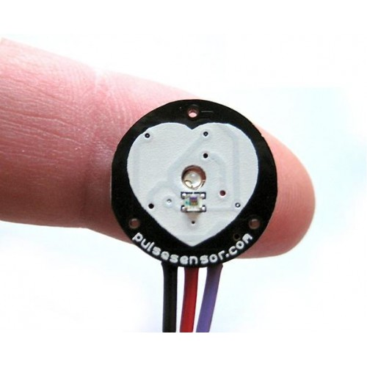

The sensor clips onto a fingertip or earlobe and with some jumper cables. It also includes an open-source monitoring app that graphs your pulse in real time. It essentially combines a simple optical heart rate sensor with amplification and noise cancellation circuitry making it fast and easy to get reliable pulse readings. It calculates the pulse rate over a minute

**Pulse Sensor Specifications**

* Biometric Pulse Rate or Heart Rate detecting sensor
* Plug and Play type sensor
* Operating Voltage: +5V or +3.3V
* Current Consumption: 4mA
* Inbuilt Amplification and Noise cancellation circuit.
* Diameter: 0.625”
* Thickness: 0.125” Thick
* **Cost-: 205/-**
* **Other Sensors available-:**
* Sunrobotics MAX30100 Sensor
* SEN 11574 Sensor
* **Why** **Pulse Sensor…??**

All other sensors are not accurate as compared to other sensors and also Cost of other sensors are high as compared to the Pulse sensor. So that is why we choose this Sensor.

### **Push Button Switch (Motion Sensing for Activity and Intensity)**

### 

Here we are using Push button Switches to detect the motion of the dog. In other words we can say that to detect whether dog is in Rest or doing some activity.

**OR**

### **MPU6050 (Motion Sensor for Activity and Intensity)**

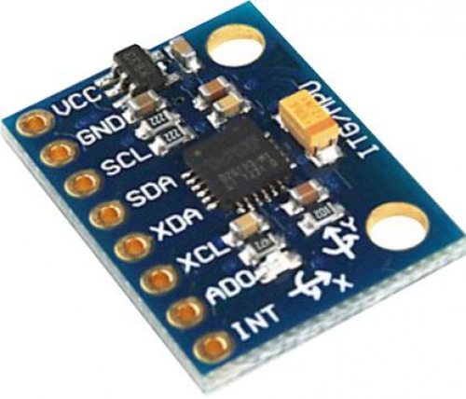

### **MPU6050 Features-:**

* MEMS 3-axis accelerometer and 3-axis gyroscope values combined
* Power Supply: 3-5V
* Built-in 16-bit ADC provides high accuracy
* Built-in DMP provides high computational power
* Can be used to interface with other IIC devices like the magnetometer
* **Cost-: 320/-**
* **Other Sensors available-:**
* HC-SR501 PIR Motion Sensor
* Suzec PIR Sensors
* HC-SR505 PIR Motion Sensor
* **Why MPU6050 Motion Sensor…??**
* We used this sensor because this sensor is a combination of accelerometer and gyroscope.
* Can be used to interface with other IIC devices like the magnetometer
* So that is why we choose this Sensor.

1. **GPS Module NEO-6M-:**

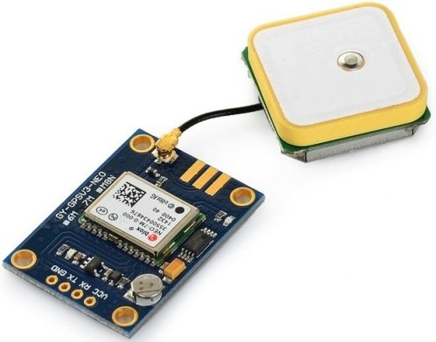

The Global Positioning System (GPS) is a satellite based navigation system that can be used to locate positions anywhere on earth. Designed and operated by the U.S. Department of Defence, it consists of satellites, control and monitor stations, and receivers. GPS receivers take information transmitted from the satellites and uses triangulation to calculate an animal‟s exact location.

**Features of NEO-6M GPS Module:-**

* 5Hz position update rate
* Operating temperature range: -40 TO 85°C UART TTL socket
* EEPROM to save configuration settings
* Rechargeable battery for Backup
* The cold start time of 38 s and Hot start time of 1 s
* Supply voltage: 3.3 V
* Configurable from 4800 Baud to 115200 Baud rates. (default 9600)
* SuperSense ® Indoor GPS: -162 dBm tracking sensitivity
* Support SBAS (WAAS, EGNOS, MSAS, GAGAN)
* Separated 18X18mm GPS antenna
* **Cost-: 520/-**

### **ESP8266-01 ( Wifi Module)-:**

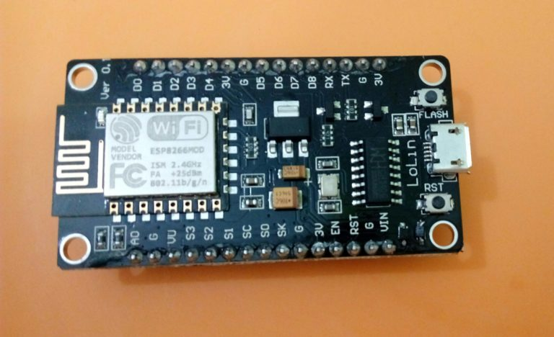

### **ESP8266-01 Features-:**

* Low cost, compact and powerful Wi-Fi Module
* Power Supply: +3.3V only
* Current Consumption: 100mA
* I/O Voltage: 3.6V (max)
* I/O source current: 12mA (max)
* Built-in low power 32-bit MCU @ 80MHz
* 512kB Flash Memory
* Can be used as Station or Access Point or both combined
* Supports Deep sleep (<10uA)
* Supports serial communication hence compatible with many development platforms like Arduino
* **Cost-: 250/-**
* **Why ESP8266-01…??**
* It consists of a Tensilica L106 32-bit microcontroller unit (MCU) and a Wi-Fi transceiver.
* Also, it has a small size as well as its cost is also less.
* **Other Required Components-**:

1. Connecting Wires (Male female and Male to Male)
2. Breadboard for Connections
3. Rechargeable Battery **(Lipo Battery Model KP-502530 1000mA)**

# TP4056 1A Li-Ion Battery Charging Board Micro USB with Current Protection

* **Block Diagram Of Our Project-:**

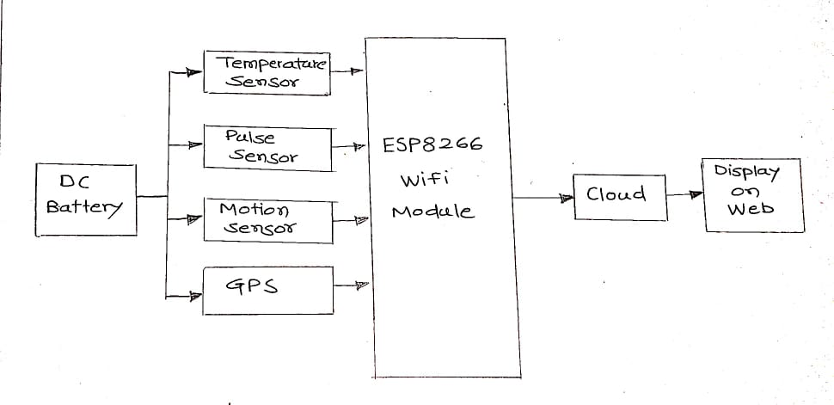

This is the Block Diagram Of our Project. In which we are included all the sensors and modules which we are used in this project.

* **Block Diagram Of IOT Implementation-:**

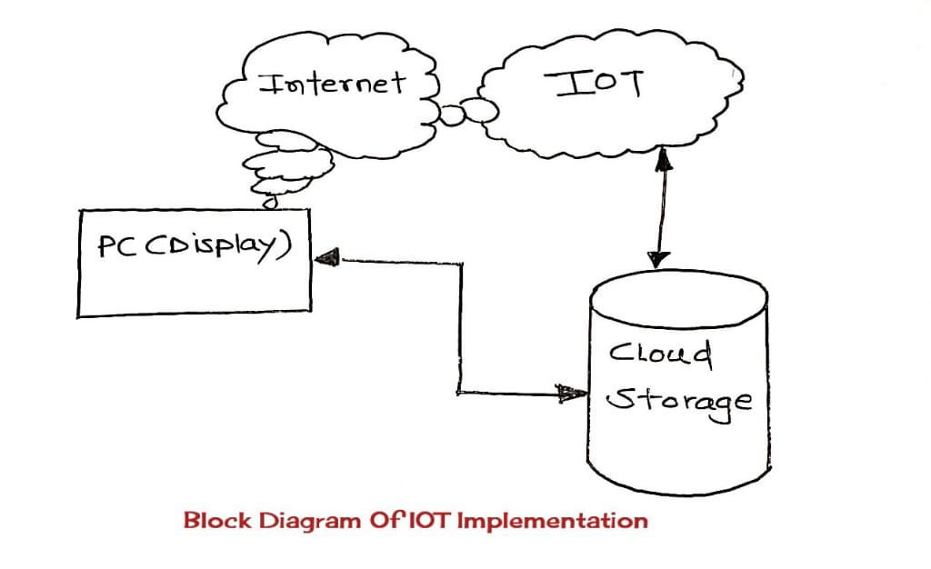

The Internet of Things (IoT) is a network of physical objects—devices, vehicles, buildings and other items embedded with electronics, software, sensors, and network connectivity—that enables these objects to collect and exchange data. IoT allows objects to be sensed and controlled remotely across existing network infrastructure, creating opportunities for more direct integration between the physical world and computer-based systems, and resulting in improved efficiency, accuracy and economic benefit.

* **Interfacing Diagrams Of Sensors with ESP8266-:**

1. **DS18B20 Temperature Sensor-:**

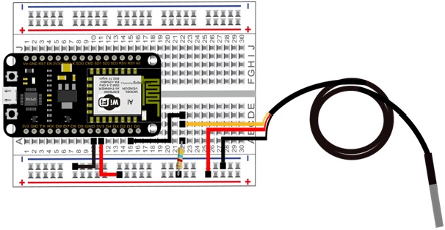

1. **Push Button Switch (Motion Sensing for Activity and Intensity)**

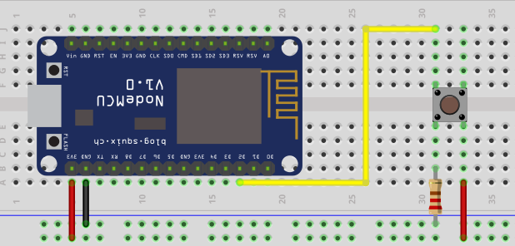

1. **GPS Module NEO-6M-:**

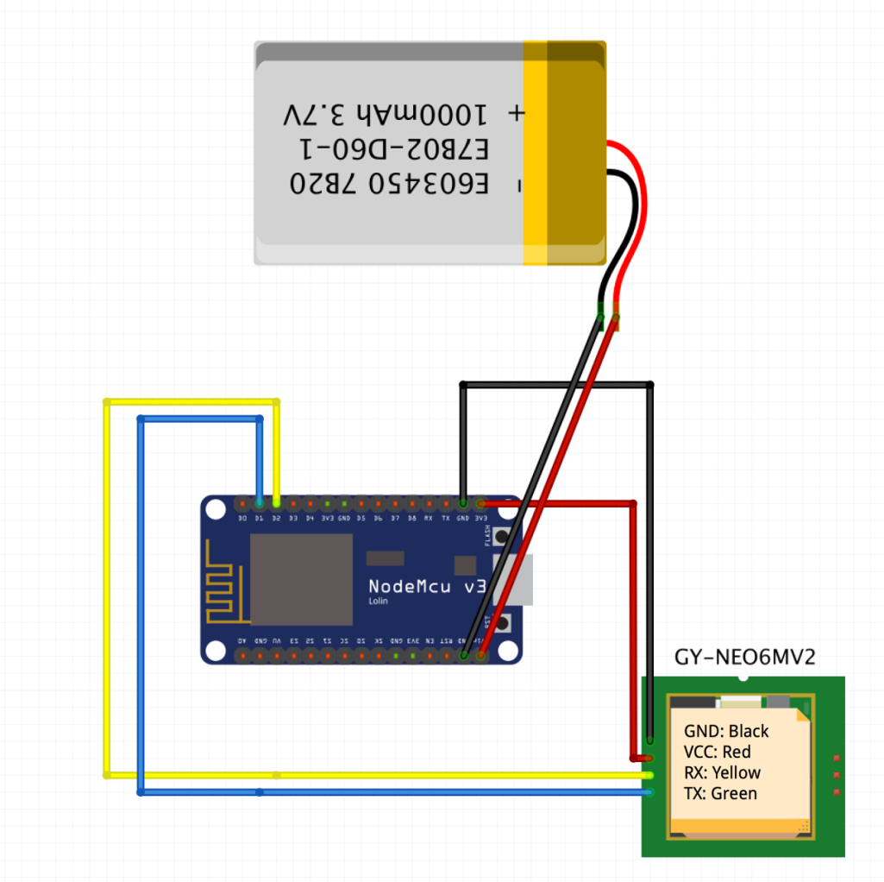

### **ESP8266-01 ( Wifi Module) with battery-:**

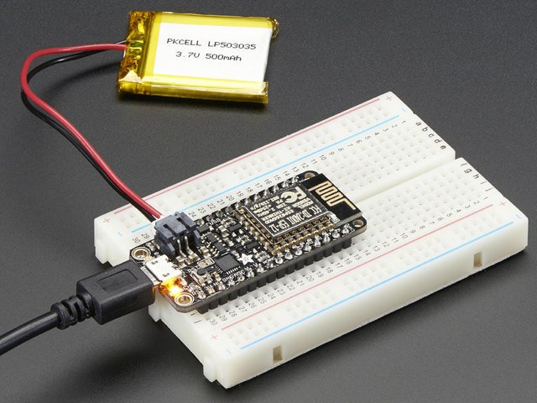

This are the interfacing diagrams of our project.

* **Comparison with other product-:**

|  |  |  |  |  |  |  |  |  |
| --- | --- | --- | --- | --- | --- | --- | --- | --- |
| **PARAMETERS** | **Our**  **Product** | **Wagr** | **Tagg— The Pet Tracker** | **Whistle Go** | **Fi**  **collar** | **Link Akc Smart Dog Collar** | **FitBark 2 Dog Activity Monitor** | **Find My Pet GPS Pet Tracker** |
| **TEMPERATURE SENSOR** | **YES** | **NO** | **NO** | **NO** | **NO** | **YES** | **NO** | NO |
| **PULSE SENSOR** | **YES** | **NO** | **NO** | **NO** | **NO** | **NO** | **NO** | NO |
| **MOTION SENSOR** | **YES** | **YES** | **YES** | **YES** | **YES** | **YES** | **YES** | YES |
| **GPS AVAILABILITY** | **YES** | **YES** | **YES** | **YES** | **YES** | **YES** | **NO** | YES |
| **WATERPROOF**  **(upto certain limit)** | **YES** | **YES** | **YES** | **YES** | **YES** | **YES** | **YES** | YES |
| **COST** | **APPROX 2500/-** | **5999/-** | **6999/-** | **7162./-** | **10281/-** | **6900/-** | **4830/-** | 3786/- |
| **BATTERY LIFE**  **(depend on usage)** | **1 DAY** | **3 DAYS** | **2 DAYS** | **8-10 DAYS** | **4.5 DAYS** | **3 DAYS** | **1 DAY** | **4 DAYS** |

* **Is there any radiation effect occurs due to Components??**

There is no radiation effect occur due to Components because from research we studied that, the body temperature of dog and human body is approximately the same. If we take an example of simple smartphone which operates on 5V DC supply. Smartphone also having small amount of radiation effect but it doesn't affect our human body.

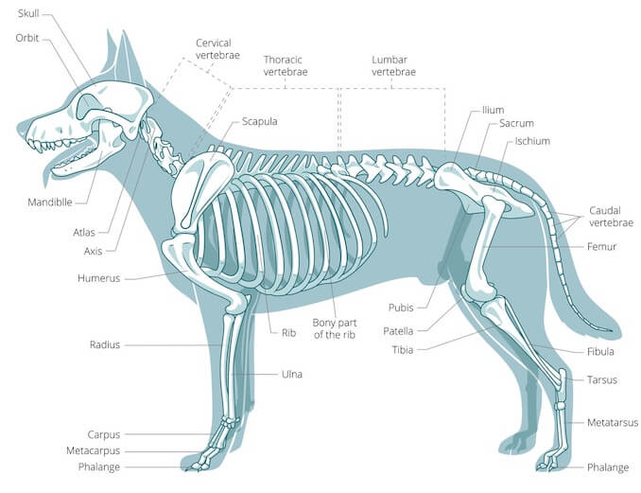

And the second main reason is that, In nature our environment exhibits a large amount of radiation effect for example-: Solar radiation, Temperature, Wind, Humidity, etc. which does not affect animals body or animals health.

This concept is clearly mentioned in given link-:

<https://www.researchgate.net/publication/221929764_Effects_of_Solar_Radiation_on_Animal_Thermoregulation>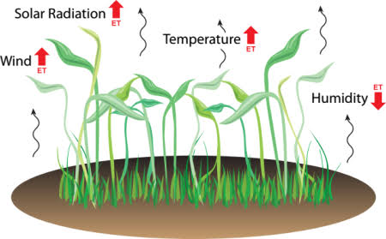

* **Snapshot-**:

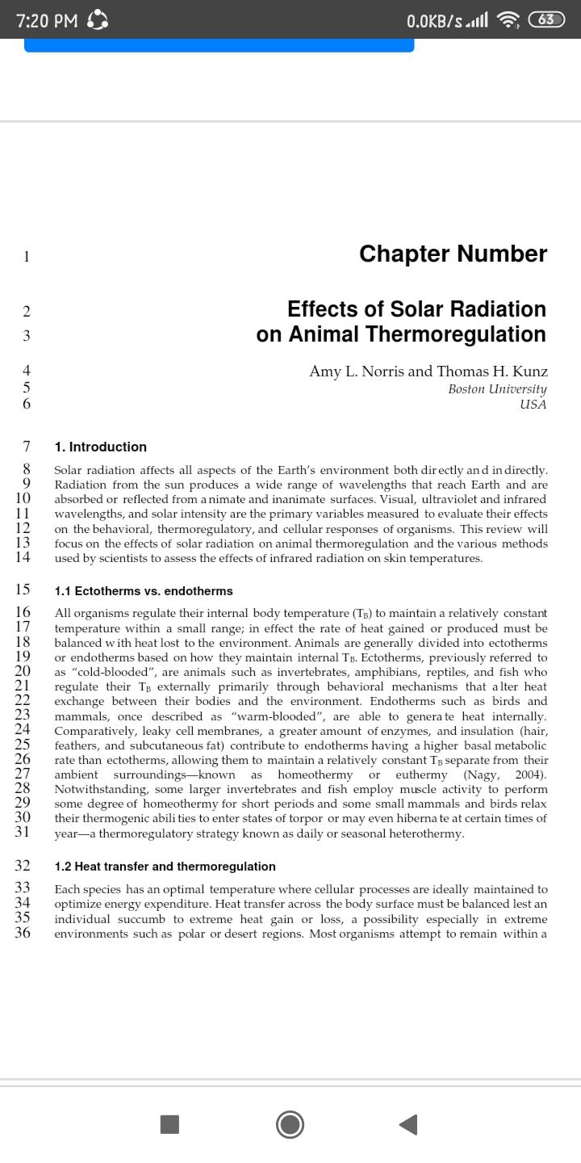

This states that radiation effect does not affect dog’s body.

* **Animal models for medical countermeasures to radiation exposure-:**

Jacqueline P Williams, Stephen L Brown, George E Georges, Martin Hauer-Jensen, Richard P Hill, Amy K Huser, David G Kirsch, Thomas J MacVittie, Kathy A Mason, Meetha M Medhora, John E Moulder, Paul Okunieff, Mary F Otterson, Michael E Robbins, James B Smathers, William H McBride

Radiation research 173 (4), 557-578, 2010

Since September 11, 2001, there has been the recognition of a plausible threat from acts of terrorism, including radiological or nuclear attacks. A network of Centers for Medical Countermeasures against Radiation (CMCRs) has been established across the U.S.; one of the missions of this network is to identify and develop mitigating agents that can be used to treat the civilian population after a radiological event. The development of such agents requires comparison of data from many sources and accumulation of information consistent with the “Animal Rule” from the Food and Drug Administration (FDA). Given the necessity for a consensus on appropriate animal model use across the network to allow for comparative studies to be performed across institutions, and to identify pivotal studies and facilitate FDA approval, in early 2008, investigators from each of the CMCRs organized and met for an Animal Models Workshop. Working groups deliberated and discussed the wide range of animal models available for assessing agent efficacy in a number of relevant tissues and organs, including the immune and hematopoietic systems, gastrointestinal tract, lung, kidney and skin. Discussions covered the most appropriate species and strains available as well as other factors that may affect differential findings between groups and institutions. This report provides the workshop findings.

See More details on-: <https://scholar.google.co.in/scholar?q=radiation+effect+of+sensors+on+animal&hl=en&as_sdt=0&as_vis=1&oi=scholart#d=gs_qabs&u=%23p%3DUG8134UPlKMJ>

* **Biological sensors for solar ultraviolet radiation-:**

Teiti Yagura, Kazuo Makita, Hiromasa Yamamoto, Carlos FM Menck, André P Schuch

Sensors 11 (4), 4277-4294, 2011

Solar ultraviolet (UV) radiation is widely known as a genotoxic environmental agent that affects Earth ecosystems and the human population. As a primary consequence of the stratospheric ozone layer depletion observed over the last decades, the increasing UV incidence levels have heightened the concern regarding deleterious consequences affecting both the biosphere and humans, thereby leading to an increase in scientific efforts to understand the role of sunlight in the induction of DNA damage, mutagenesis, and cell death. In fact, the various UV-wavelengths evoke characteristic biological impacts that greatly depend on light absorption of biomolecules, especially DNA, in living organisms, thereby justifying the increasing importance of developing biological sensors for monitoring the harmful impact of solar UV radiation under various environmental conditions. In this review, several types of biosensors proposed for laboratory and field application, that measure the biological effects of the UV component of sunlight, are described. Basically, the applicability of sensors based on DNA, bacteria or even mammalian cells are presented and compared. Data are also presented showing that on using DNA-based sensors, the various types of damage produced differ when this molecule is exposed in either an aqueous buffer or a dry solution. Apart from the data thus generated, the development of novel biosensors could help in evaluating the biological effects of sunlight on the environment. They also emerge as alternative tools for using live animals in the search for protective sunscreen products.

See More details on-: <https://scholar.google.co.in/scholar?q=radiation+effect+of+sensors+on+animal&hl=en&as_sdt=0&as_vis=1&oi=scholart#d=gs_qabs&u=%23p%3DUG8134UPlKMJ>